 Validation Rules

Investigation Exercise

In this exercise, you will create two validation rules and observe their effects.

For the sake of reference, the five validation levels in the base application, in order, are:

Loadsave --> New Loss Completion --> Valid for ISO --> Send to external (system) --> Ability to pay

1. Inside the Claim Validation rule set, enter the following rule:

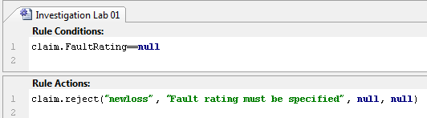

1a) Do you think this rule will raise a warning? If so, at what level?
1b) Do you think this rule will raise an error? If so, at what level?
(You do not need to actually test the rule at this point.)

2. Inside the Claim Validation rule set, enter the following rule:

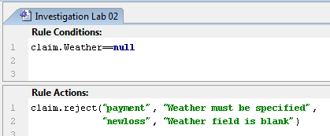

2a) Do you think this rule will raise a warning? If so, at what level?
2b) Do you think this rule will raise an error? If so, at what level?
(You do not need to actually test the rule at this point.)

3. Create a new auto claim. However, on the Loss Details step, leave both the Fault Rating and Weather fields blank. Can you save the claim? Are both validation messages displayed?

4. Specify the Fault Rating as "No fault" and save the claim.

4a) What is the claim's validation level?
4b) How did the claim get beyond "new loss completion"?
4c) Why isn't the claim at "ability to pay"?

5. For the saved claim, attempt to set the Fault Rating back to "none selected". What happens? Why?

6. Using the claim's Actions menu, validate the claim at "new loss completion". Then, validate the claim at "ability to pay". Were the validation results the same?

7. Change the claim's Weather field to Clear. What is the claim's validation level now?

8. Disable the two rules you created at the start of the lab. (This will prevent them from interfering with any other work you do later in the course.)

Configuration Exercise

Configure ClaimCenter to meet the following customer requirement from Acme Insurance.

Requirement 1: Validation for Claim Fields

Acme Insurance has the following requirements for claims:

Claim - new loss completion
- If the loss cause is either "Theft Audio or other parts" or "Theft of entire vehicle", there must be at least one police report listed. (Police reports are listed in the Metropolitan Reports list on the Loss Details page.)
- If the Fault Rating is "no fault" and the loss location's state is California (CA) or New York (NY), warn the user that the given state is not a "no fault" state, but let the claim be saved.

Claim - valid for ISO
- The claim must have a description. Highlight the field.

9. Write the claim validation rule(s) needed to enforce the behavior above.

Test Case 1

When you have completed your configuration, run the following test cases:

10. Log on to ClaimCenter as Andy Applegate. Create a new auto claim. On step 4, make sure that:
- The "What Happened?" field (description) is blank.
- The loss cause is set to one of the theft options.
- The loss location state is set to California.
- There are no police reports.
- The fault rating is set to "no fault".

11. Attempt to save the claim. Verify that it cannot be saved because of the missing police report.

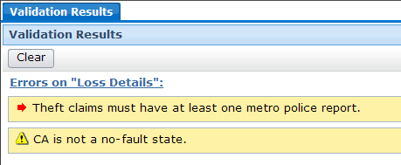

12. Add a police report. (You only need to specify the required values.) Verify that that claim can be saved, and that it is at "new loss completion".

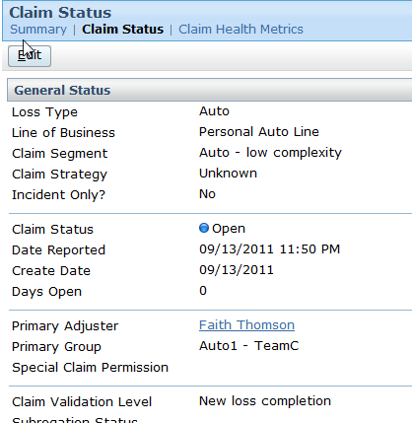

13. Navigate to the Loss Detail page. Use the Validate Claim menu item to validate the claim for "New loss completion". Verify that the warning appears.

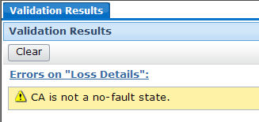

14. While still on the Loss Detail page, use the Validate Claim menu item to validate the claim for "Valid for ISO". Verify that it states the description must be provided and that the description field is flagged with a red arrow.

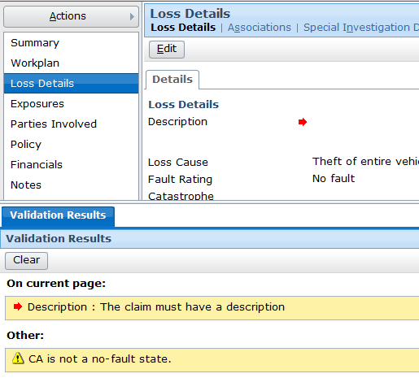

15. Provide a description and save the claim. (You may also need to verify that coverage is not in question.) Verify that the claim is now at or beyond "Valid for ISO".

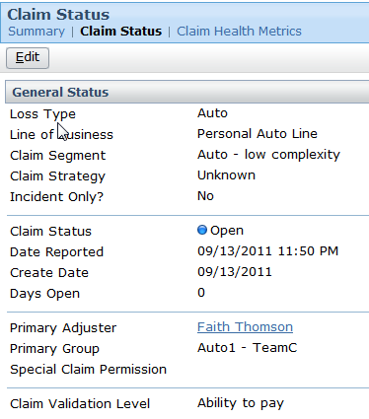

Challenge Exercises

Complete these requirements only if your instructor tells you to do so.

Requirement 2: Validation for Exposure Lists

Acme Insurance has the following requirements for exposures:

Sending exposure to outside systems (send to external)
- In the Other Carrier Involvement list, if a listed insurer has a contact (a name in the contact field), then the corresponding phone number field cannot be blank. (If it is, flag that field.)

16. Write the exposure validation rule(s) needed to enforce the behavior above.

Test Case 2

(To simplify testing, disable the Exposure Validation ISO rules.) When you have completed your configuration, run the following test cases:

17. Attempt to create a new collision exposure in which there is at least one Other Carrier Involvement carrier with a contact and no phone number. Verify the exposure can be saved but that it cannot reach "send to external".

18. Add phone numbers to all Other Carrier Involvement carriers with contacts. Verify the exposure is now at or beyond "send to external".

19. Attempt to remove the phone number for an Other Carrier Involvement contact. Verify the change cannot be saved and that the field is flagged.

